 Hale School

Semester 1, 2011

Question/Answer Booklet

MATHEMATICS
Circle your teacher’s initials

MRC MAV

SPECIALIST 3CD

Section One

(Calculator Free)

Your name

Time allowed for this section

Reading time before commencing work: 5 minutes
Working time for paper: 50 minutes

Material required/recommended for this section

To be provided by the supervisor
Question/answer booklet for Section One.
Formula sheet.

To be provided by the candidate
Standard items: pens, pencils, pencil sharpener, highlighter, eraser, ruler.

Important note to candidates

No other items may be taken into the examination room. It is your responsibility to ensure that you do not have any unauthorised notes or other items of a non-personal nature in the examination room. If you have any unauthorised material with you, hand it to the supervisor before reading any further.

Structure of this examination

 | Number of questions | Working time (minutes) | Marks available
This Section (Section 1)  Calculator Free | 7 | 50 | 40
Section Two  Calculator Assumed | 13 | 100 | 80
Total marks |  |  | 120

Instructions to candidates

- The rules for the conduct of WACE external examinations are detailed in the booklet WACE Examinations Handbook. Sitting this examination implies that you agree to abide by these rules.

- Answer the questions in the spaces provided.

- Spare answer pages are provided at the end of this booklet. If you need to use them, indicate in the original answer space where the answer is continued i.e. give the page number.

- Show all working clearly. Your working should be in sufficient detail to allow your answers to be checked readily and for marks to be awarded for reasoning. Incorrect answers given without supporting reasoning cannot be allocated any marks. Any question, or part question, worth more than 2 marks requires valid working or justification to receive full marks. If you repeat an answer to any question, ensure that you cancel the answer you do not wish to have marked.

It is recommended that you do not use pencil except in diagrams.

1. [3 marks]

Use an inverse matrix method to solve the matrix equation

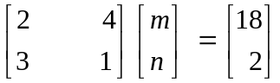
2. [7 marks]

Determine:

(a) 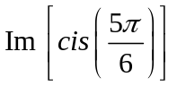

[2]

(b) 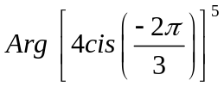

[2]

(c) Describe the locus of points z on the Argand plane defined by the rule:

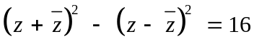

[3]
3. [6 marks]
For each of the following functions, find  in terms of x.
(a) 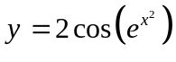

[2]

(b) 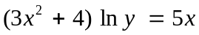

[4]
4. [7 marks]

(a) Write 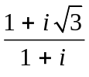 in cis form.

[2]

(b) Hence, determine the exact value of 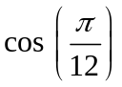.

[3]

(c) By using the result from (a), or otherwise, calculate 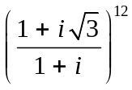.

[2]
5. [5 marks]

(a) Prove that 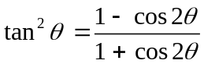

[2]

(b) Hence determine the exact value of 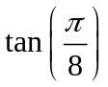

[3]
6. [6 marks]

Evaluate the following limits, showing full reasoning.

(a) 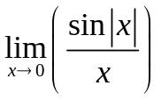

[3]

(b) 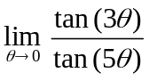

[3]
7. [6 marks]

Relative to an origin O, point A has cartesian coordinates (1, 2, 2) and point B has cartesian coordinates (–1, 3, 4).

(a) Find an expression for the vector 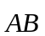.

[1]

(b) Show that the cosine of the angle between the vectors 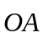 and is 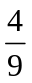.

[2]

(c) Hence determine the exact area of the triangle OAB.

[3]
SPARE PAGE FOR WORKING
SPARE PAGE FOR WORKING

